How to Sign Up on Twitter

To create an account:
- Go to http://twitter.com and find the sign up box, or go directly to https://twitter.com/signup.
- Enter your full name, email address, and a password.
- Click Sign up for Twitter.
- On the next page, you can select a username (usernames are unique identifiers on Twitter) — type your own or choose one we've suggested. We'll tell you if the username you want is available.
- Double-check your name, email address, password, and username.
- Click Create my account.You may be asked to complete a Captcha to let us know that you're human.
- Twitter will send a confirmation email to the address you entered on sign up, click the link in that email to confirm your email address and account.

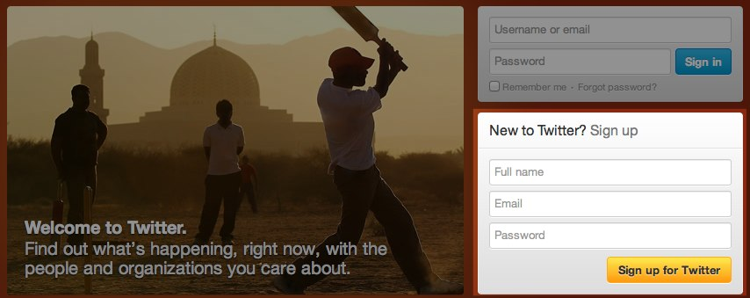

Tips for picking a username:
- Your username is the name your followers use when sending @replies, mentions, and direct messages.
- It will also form the URL of your Twitter profile page. We'll provide a few available suggestions when you sign up, but feel free to choose your own.
- Please note: You can change your username in your account settings at any time, as long as the new username is not already in use.
- Usernames must be fewer than 15 characters in length and cannot contain "admin" or "Twitter", in order to avoid brand confusion.

Important information about your email address:
- An email address can only be associated with one Twitter account at a time.
- The email address you use on your Twitter account is not publicly visible to others on Twitter.
- We use the email you enter to confirm your new Twitter account. Be sure to enter an email address that you actively use and have access to. Check your inbox for a confirmation email to make sure you signed up for your account correctly.

First steps after you've created your account:
- After signing up, follow a handful of accounts to create a customized stream of information on your homepage. Following means you'll get that user's Tweets on your Twitter homepage. You can unfollow anyone at any time. Find out how to follow news sources, friends, and more in our How to Find People on Twitter article.
- Read our Twitter 101 article.
- Take the Twitter Tour to find out where things are on our website. Or, learn about using Twitter on your mobile phone.
Related Articles:
- Get to Know Twitter: New User FAQ
- The Twitter Glossary
- Why Can't I Register Certain Usernames?

Having Trouble?
Check out our Account settings troubleshooting articles for solutions to common problems.

